TECHNICAL PROJECT REPORT

# Title of Project:

# VOICE CONTROL EXTENTION BOARD

# Team Members / Inventors:

|  |  |  |  |  |  |
| --- | --- | --- | --- | --- | --- |
| **S. No.** | **Name** | **Department** | **Designation** | **Mobile** | **E-Mail** |
| 1. | RITISH AGGARWAL | ECE | STUDENT | 7696941120 | ritishaggarwal26@gmail.com |
| 2. | SURAJ | ECE | STUDENT | 7901814949 | gsuraj349@gmail.com |
| 3. | MAYANK PANDEY | ECE | STUDENT | 8092104870 | ipandeymayank@gmail.com |
| 4. | Khushal Thakur | ECE | Mentor | 9646030764 | khushal.thakur@cumail.in |
| 5. | Anshul Sharma | ECE | Mentor | 9478697475 | anshulsharma.ece@cumail.in |
| 6. | Kiran Jot Singh | ECE | Mentor | 9463909689 | kiranjotsingh.ece@cumal.in |
| 7. | Divneet Singh Kapoor | ECE | Mentor | 9878422653 | divneet.ece@cumail.in |

Section – 1 (IPR Related)

# Abstract

Good Sir, we are making voice activated home automation. In this device we use Arduino UNO, relay 5V, and Bluetooth as main component. This device can operates any electrical device with our voice takes the Bluetooth and sent to Ardiuno and then sent to relay board and the circuit becomes working.

Due to this device, if anyone feels ill and cannot be able to go to the switch board, so he/she can directly speak on their smartphone & then their command as a data to that device. Furthermore, the device will do what he/she want to be work.

In this device, we use Bluetooth module. Due to this, its range only between – 1-15m. So, if we have to increase the range then we have to use WI-FI module for long distance. However, the device need internet connection due to give our command to the Bluetooth module without internet connection it will not work.

Existing state-of-the-art and Drawbacks in existing state-of-the-art

|  |  |  |
| --- | --- | --- |
| **S. No.** | **Existing state of art** | **Drawbacks in existing state of art** |
| 1 | https://www.kickstarter.com/projects/seeed/respeaker-an-open-modular-voice-interface-to-hack | Mainly, the range matters the Bluetooth connection range is very less. Always need internet connection. |

# Novel/Additional modifications that you can propose to improve upon drawbacks

* We introduce Bluetooth module without using internet connection that can improve on drawback.

# Advantages

* LOSE THE REMOTE

In your home’s [media room](https://audio-one.com/interiors/interiors-home), your remote control holds all the power. If all your technologies are part of an integrated home automation system, then the remote controls not only the volume and channel but also the lights and shades. Therefore, losing the remote can be a big inconvenience.Of course, you can get up to make adjustments or find the remote, but why do that when you can just ask Alexa? You can use voice control to change the channel, adjust the volume, or change the media playing. With voice control, losing the remote is no big deal.

* AGED PEOPLE

Home automation is being implemented into more and more homes of older adults and people with disabilities in order to maintain their independence and safety. These smart homes allow older adults and people with disabilities to stay in their homes where they feel comfortable, instead of moving to a costly health care facility. The transition to a health care facility can cause a lot of anxiety and home automation can either prevent or delay this anxiety. For the disabled smart homes give them opportunity for independence, which will help them gain confidence and determination. Smart homes can provide both older adults and people with disabilities with many different types of emergency assistance systems, security features, fall prevention, automated timers, and alerts.

# Block Diagram

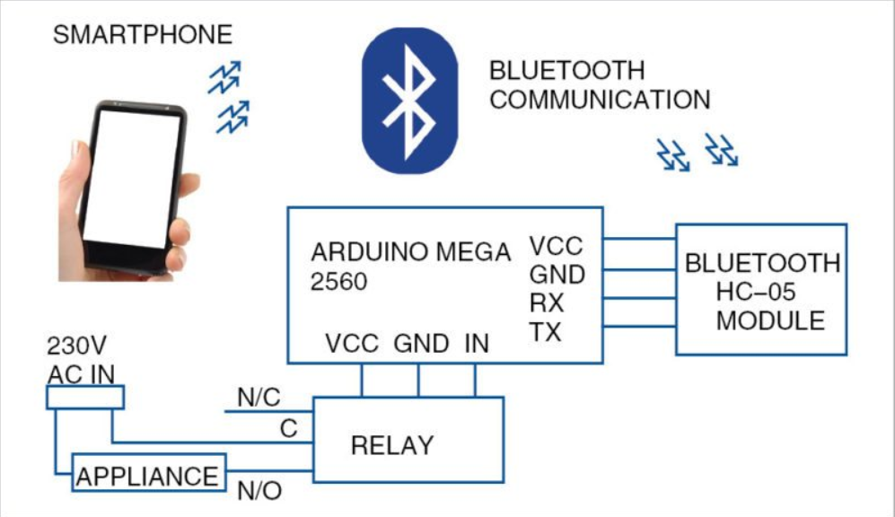

Section – 2 (Real Project)

# Materials

|  |  |  |
| --- | --- | --- |
| COMPONENTS | QUANITIY | PRICE |
| Arduino UNO | 1 | 500 |
| Bluetooth Module | 1 | 350 |
| Relay 5V | 1 | 350 |
| Battery 9V | 1 | 20 |
| Sockets | 4 | 80 |
| Jump Wires | 20 | 100 |
|  | Total | 1400 |

# Circuit Diagram

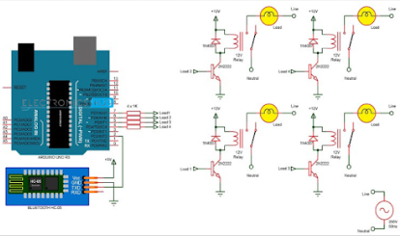

# Steps of Circuit Completion

1. Check all the component like Bluetooth , relay 5V , Arduino Uno individually.

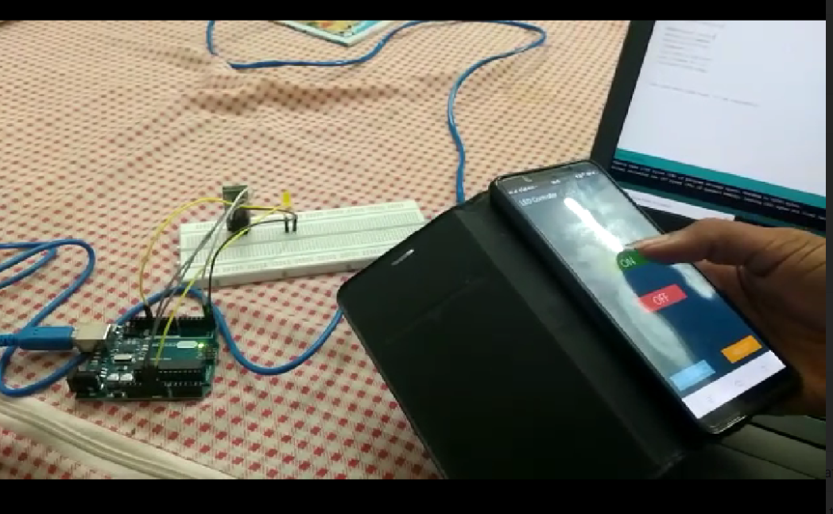

2.Then connect the Bluetooth terminal ( 5v) to Arduino 3.3v and GND to Arduino GND.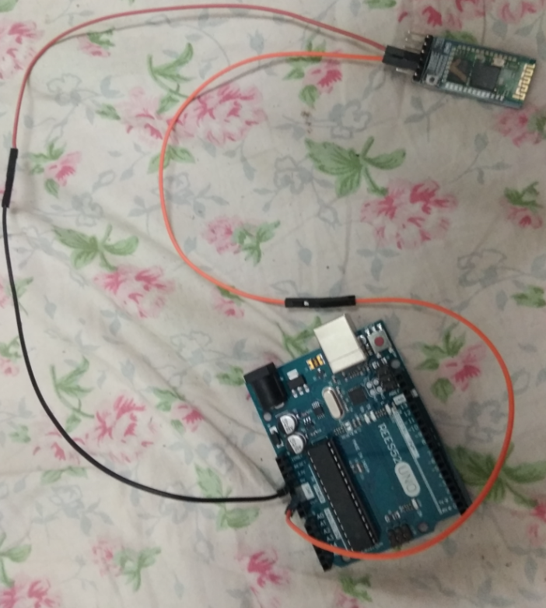

3.Then connect the relay terminal as VCC to 5v Arduino and relay GND to Arduino GND.

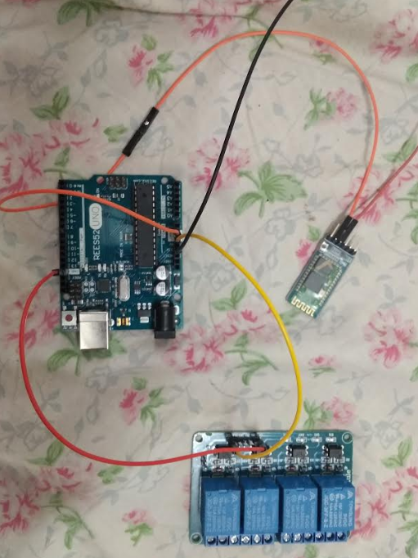

4.Connect the relay terminal as load 1,2,3,4 to Arduino pin 4,5,6,7 .

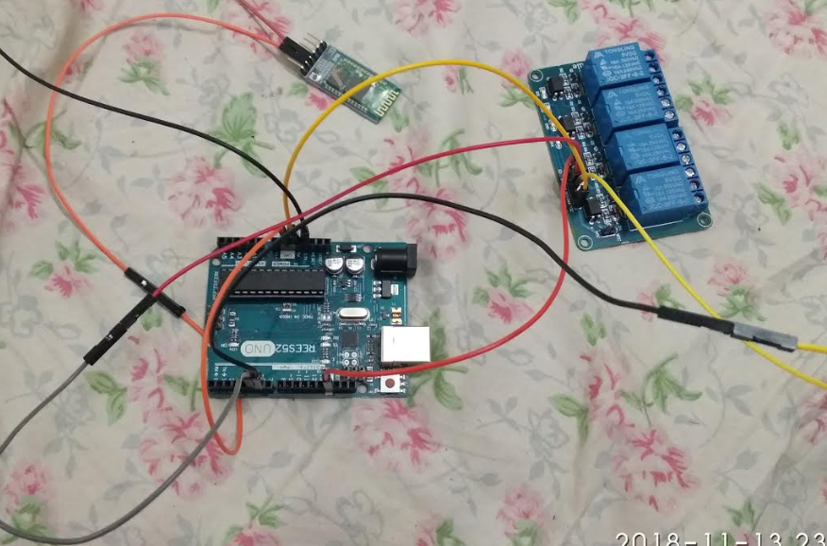

5.Then we use the first two terminal of every channel in the relay where the left side is normally open and centre terminal is normally closed.

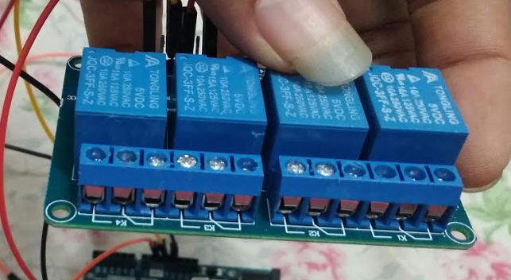

6.Insert the wire in the normally open terminal which is connect to sockets.

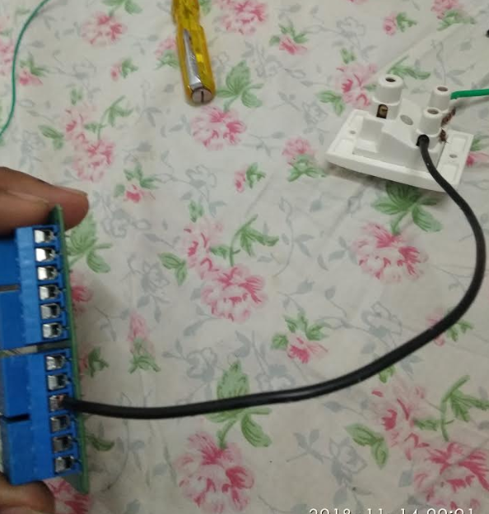

7.In socket the another wire is connected to the ac supply.

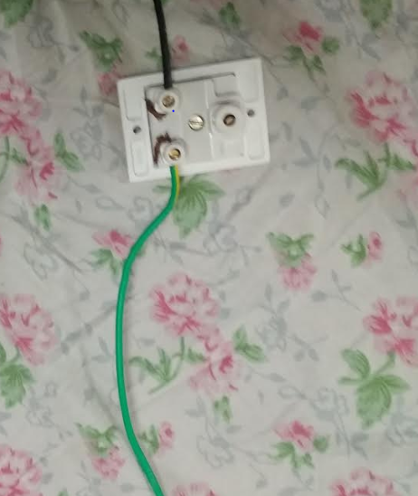

8.Insert a another wire in normally closed which is connected to ac supply.

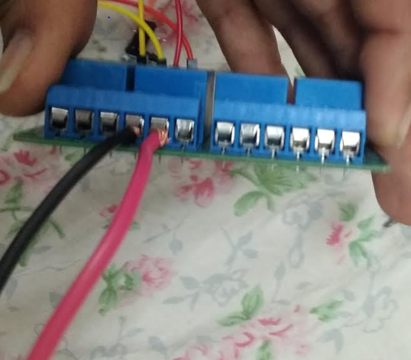

9.write the code and upload to the Arduino.

10.Install the app in your mobile.

# Program Code

https://github.com/Ritishagg/Voice-Controlled-Extention-Board-for-AC-Appliances/blob/master/Program/suraj_voice.ino